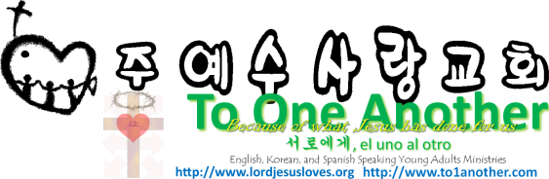
Why is Jesus the Only Way to Salvation?
Pastor Yoo Nam Kang
John 3:16
Scriptures in New Living Translation
November 11, 2012

John 3:16
“For God loved the world so much that he gave his one and only Son, so that everyone who believes in him will not perish but have eternal life.
Acts 2:36
“So let everyone in Israel know for certain that God has made this Jesus, whom you crucified, to be both Lord and Messiah!”
Acts 5:42
And every day, in the Temple and from house to house, they continued to teach and preach this message: “Jesus is the Messiah.”

1. Forgiveness of Sins Is Only In Jesus
Ephesians 1:7
He is so rich in kindness and grace that he purchased our freedom with the blood of his Son and forgave our sins.

2. Eternal Life is Only in Jesus
John 3:16
“For God loved the world so much that he gave his one and only Son, so that everyone who believes in him will not perish but have eternal life.
1John 5:11-12
11 And this is what God has testified: He has given us eternal life, and this life is in his Son. 12 Whoever has the Son has life; whoever does not have God’s Son does not have life.
John 1:29
The next day John saw Jesus coming toward him and said, “Look! The Lamb of God who takes away the sin of the world!
John 3:3
Jesus replied, “I tell you the truth, unless you are born again, you cannot see the Kingdom of God.”
John 1:12
But to all who believed him and accepted him, he gave the right to become children of God.
2Corinthians 3:18
So all of us who have had that veil removed can see and reflect the glory of the Lord. And the Lord—who is the Spirit—makes us more and more like him as we are changed into his glorious image.
John 14:27
“I am leaving you with a gift—peace of mind and heart. And the peace I give is a gift the world cannot give. So don’t be troubled or afraid.

3. Mind of Jesus is Salvation
1Corinthians 2:16
For, “Who can know the Lord’s thoughts? Who knows enough to teach him?” But we understand these things, for we have the mind of Christ.
John 1:1-3,14
1 In the beginning the Word already existed. The Word was with God, and the Word was God. 2 He existed in the beginning with God. 3 God created everything through him, and nothing was created except through him. 14 So the Word became human and made his home among us. He was full of unfailing love and faithfulness. And we have seen his glory, the glory of the Father’s one and only Son.
Colossians 1:15-16
15 Christ is the visible image of the invisible God. He existed before anything was created and is supreme over all creation, 16 for through him God created everything in the heavenly realms and on earth. He made the things we can see and the things we can’t see— such as thrones, kingdoms, rulers, and authorities in the unseen world. Everything was created through him and for him.
1Corinthians 2:16
For, “Who can know the Lord’s thoughts? Who knows enough to teach him?” But we understand these things, for we have the mind of Christ.

